BDO India LLP
As-Is analysis of UPSRLM Training Management and Reporting Cycle Key Process Steps: 1. Annual Action Planning (AAP) Process 2. Training Execution Process 3. Financial Settlement Process 4. MIS Reporting Process Recording Period: 17th September 2025 to 20th September 2025
U.P. STATE RURAL LIVELIHOODS MISSION Lucknow, Uttar Pradesh

Document Details
Project Name | As-Is Process Study-UPSRLM Training Management and Reporting Cycle
Date: | 17-09-2025 | Release | Ver 2.0
Author | Ayush M Srivastava
Owner | BDO India LLP
Client | U.P. State Rural Livelihoods Mission (PRERNA)
Document Number | BDO-UPSRLM-AIPS-v2-TMS’2025

Approvals
Name | Title | Date of Issue | Version
Sachin A Kumar | Project Manager-BDO India LLP | 20-09-2025 | 2.0
Team BDO |  |  | 2.0

Distribution
Name | Title | Date of Issue | Version
Ms. Deepa Ranjan | Mission Director (MD), UPSRLM | 20-09-2025 | 2.0
Ms. Niti Shrivastav | Joint Mission Director (JMD), UPSRLM | 20-09-2025 | 2.0

Table of Contents
1. Introduction 4
1.1. Governance and the Administrative Support Structure for Training 4
1.2. Thematic Leadership and Reporting Relationships 4
1.3. Delegation of Administrative and Financial Powers 5
2. Strategic Planning: The Annual Action Plan (AAP) and Budgetary Workflows 0
2.1. The Bottom-Up Planning Cycle 0
2.2. Budgetary Control and Fund Flow Mechanism 0
2.3. Annual Action Planning (AAP) Process Map 8
2.4. AAP Process Map File 8
2.5. Annual Action Planning (AAP) Process 8
2.5.1. Objective 8
2.5.2. Process Steps 8
2.5.3. Organizational Levels Involved 9
2.5.4. Identified Delays 9
3. Training Execution Process 10
3.1. The Sourcing and Empanelment of Training Personnel 10
3.2. Recruitment of Mission Staff 10
3.3. Empanelment of Resource Persons and Master Trainers 10
3.4. Community-Level Capacity Building: Standardized Training Modules 10
3.5. Training Modules for SHG and VO Members 10
3.6. Specialized Training for Community Cadres 11
3.7. Training Execution Process Map 11
3.8. Training Execution Process Map File 11
3.9. Operational Workflows and Training Execution Logistics 12
3.9.1. Objective 12
3.9.2. Process Steps 12
3.9.3. Organizational Levels Involved 12
4. Financial Management, PFMS, and Post-Training Settlement 13
4.1. The Reimbursement Workflow 13
4.2. Statutory Compliance and Audit 13
4.3. Financial Settlement (Critical Bottleneck) Process Map 14
4.4. Financial Settlement Process Map File 14
4.5. Financial Settlement Operational Workflow 14
4.5.1. Objective 14
4.5.2. Process Steps 14
4.5.3. Organizational Levels Involved 15
4.5.4. Identified Delays 15
4.5.5. Key Bottleneck 15
5. MIS and Real-Time Reporting 16
5.1. Data Validation and Reporting Formats 16
5.2. Systemic Challenges and Procedural Bottlenecks 16
5.2.1. Administrative and Financial Delays 16
5.2.2. Reliability of Data and MIS Gaps 16
5.2.3. Remuneration Delays for Community Cadres 16
5.2.4. Future Outlook and Institutional Sustainability 16
5.3. MIS Reporting Process Map 17
5.4. MIS Reporting Process Map File 17
5.5. Operational Workflow of MIS Reporting in UPSRLM 17
5.5.1. Objective 17
5.5.2. Process Steps 17
5.5.3. Organizational Levels Involved 18
5.5.4. Identified Delays 18
5.5.5. Key Bottleneck 18
6. Transition to Self-Governance 19
6.1. Model CLFs and Lakhpati Resource Blocks 19
6.2. Summary of Key Findings 19

- Introduction
The institutional framework of the Uttar Pradesh State Rural Livelihood Mission (UPSRLM) is predicated on the fundamental principle that the rural poor possess an inherent capacity for self-improvement and economic resilience, provided they are supported by a dedicated, external structure capable of facilitating social mobilization and empowerment.
Training management is the central nervous system of this mission, serving as the primary vehicle through which professional expertise is translated into community-level action. Within the broader context of the Deendayal Antyodaya Yojana – National Rural Livelihoods Mission (DAY-NRLM), UPSRLM operates as the implementing arm in Uttar Pradesh, establishing a multi-tiered architecture of Self-Help Groups (SHGs), Village Organizations (VOs), and Cluster Level Federations (CLFs).
This report provides an exhaustive mapping of the current as-is processes governing training management, ranging from strategic planning and human resource procurement to financial settlement and technological reporting.
Recording Period:
10th September 2025 to 25th September 2025

  - Governance and the Administrative Support Structure for Training
The efficacy of training delivery is contingent upon a highly structured administrative hierarchy that ensures vertical alignment and technical fidelity across the state.
The Mission operates through three distinct levels of management:
- The State Mission Management Unit (SMMU)
- The District Mission Management Unit (DMMU)
- The Block Mission Management Unit (BMMU).
Each level possesses specific mandates regarding the conceptualization, execution, and monitoring of capacity-building initiatives.

  - Thematic Leadership and Reporting Relationships
The SMMU functions as the strategic headquarters, led by the Joint Mission Director (JMD), Additional Mission Director (AMD) and the Mission Director (MD). Training and capacity building are primarily the domain of the State Mission Manager (SMM), who coordinates with other thematic heads such as those for Financial Inclusion (FI) and Livelihoods.
These functional anchors are responsible for the development of training modules, the selection of training agencies, and the establishment of quality standards.
At the district level, the District Mission Manager (DMM) serves as the team leader for the DMMU, reporting to the SMMU while overseeing the functional anchors within the district. The BMMU, led by the Block Mission Manager (BMM), represents the cutting-edge unit that works directly with community institutions. The reporting relationship is designed to be both administrative and functional; for example, a training officer at the block level reports administratively to the BMM but works in close technical coordination with the DMM at the district level.

Level | Key Training Personnel | Primary Role in Training Lifecycle
State | State Mission Manager (SMM) | Strategy, Policy, and Module Development
District | District Mission Manager (DMM) | Coordination, Monitoring, and Fund Disbursement
Block | Block Mission Manager (BMM) | Mobilization, Logistics, and Field Execution
Field | Training Partners, Community Resource Persons (CRPs), Master Trainers (DRPs, BRPs) | Direct Training Delivery to Community

  - Delegation of Administrative and Financial Powers
The mission adheres to a policy of decentralized empowerment to ensure operational efficiency. Administrative and financial powers are largely delegated to the DMMU and BMMU levels to enable quick responses to field demands. This delegation allows district and block units to approve localized training schedules, manage participant logistics, and process minor expenditures.
However, larger thematic interventions and state-wide training programs remain under the centralized control of the SMMU to ensure uniformity in training quality. The FMTSA (Financial Management Technical Support Agency) provides critical support to the Chief Financial Accounts Officer (CFAO) at the State, assisting in the preparation of bank reconciliations and ensuring that all training-related financial transactions are synchronized through the Tally accounting system.
- Strategic Planning: The Annual Action Plan (AAP) and Budgetary Workflows
The Training management at UPSRLM is not an ad hoc activity but is integrated into a rigorous annual planning cycle known as the Annual Action Plan (AAP). This process follows a bottom-up methodology, ensuring that training inputs are aligned with the actual needs of the community institutions.

  - The Bottom-Up Planning Cycle
The AAP process is initiated between December and January for the upcoming financial year. It begins at the Village Organization (VO) level, where the Executive Committee (EC) members identify the training needs of their constituent SHGs. These VO-level plans are then consolidated by the Cluster Level Federation (CLF) nodal officer. The CLF incorporates its own strategic goals, such as leadership rotation or business development planning, into the consolidated document.
Milestone | Actor Responsible | Completion Timeline (Tentative)
VO Planning Initiation | VO Executive Committee | 1st/2nd Week of December
VO Plan Completion | BMM Support | By January 15th
CLF Consolidation | CLF Nodal Officer | Within February
District Target Setting | DMM | Late February
State-Level AAP Approval | SMMU | March
The CLF Business Planning process is anchored by a visioning exercise (Vision, Mission, Objectives, Strategy, and Activities - VMOSA), which dictates the training priorities for the year. To ensure the quality of this planning, the mission mandates that the CLF Nodal Officer must attend at least 30% of the VO planning sessions, while the DMM must verify at least 10% of the CLF-level sessions.
  - Budgetary Control and Fund Flow Mechanism
Once the AAP is finalized, the financial aspects are managed through the Public Financial Management System (PFMS) and the Single Nodal Agency (SNA) framework.
The FMTSA facilitates the allotment of funds to districts based on their physical targets. Expenditure reporting is conducted through Tally, with entries made according to specific budget heads corresponding to various training themes. This system allows the mission to track expenditure in real-time and ensures that training funds are not diverted to other administrative costs.
The preparation of Utilization Certificates (UCs) is a critical step in this workflow, as they are required for the release of subsequent funding installments from the National Rural Livelihoods Mission (NRLM).

  - Annual Action Planning (AAP) Process Map
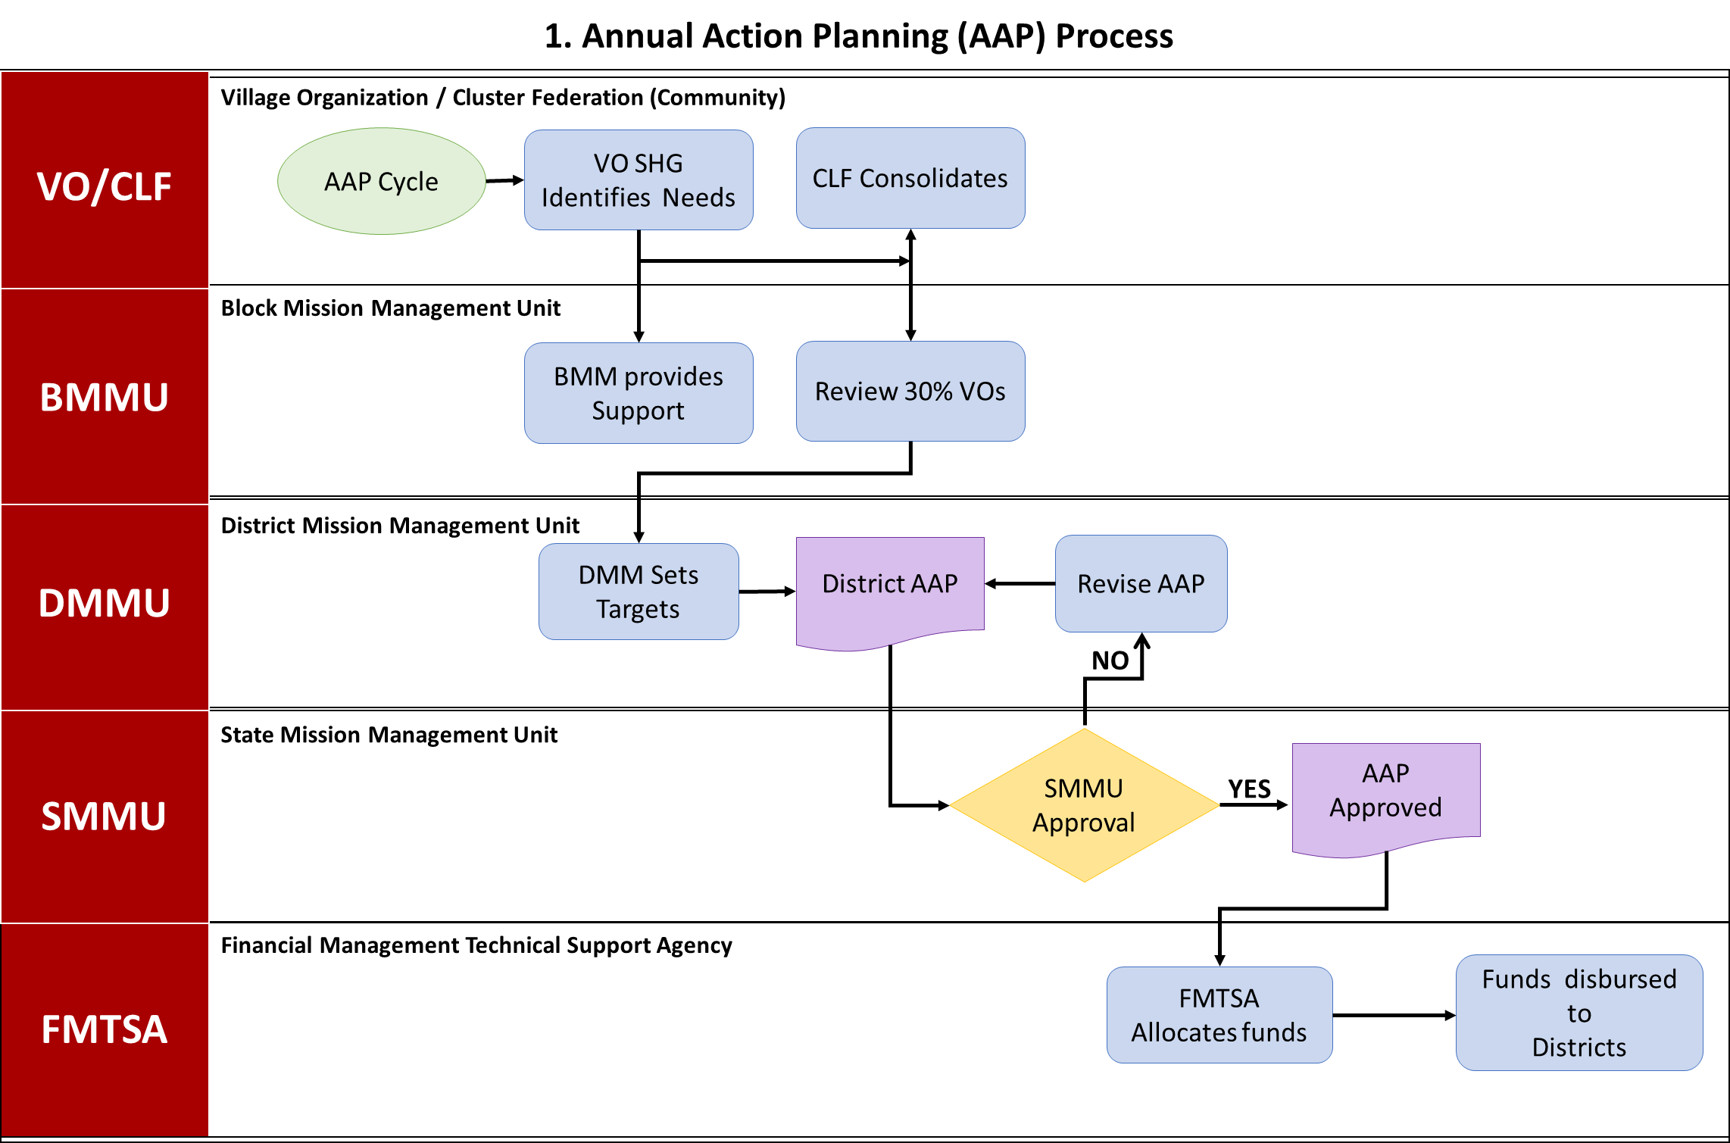

  - AAP Process Map File
  - Annual Action Planning (AAP) Process
    - Objective
To define the training needs and allocate resources for the upcoming financial year.
    - Process Steps
- VO EC Identifies Needs: (VO/CLF) - Village Organization Executive Committee identifies training needs of SHGs.
- BMM Support: (BMMU) - Block Mission Management Unit provides support to VOs in planning.
- CLF Consolidates: (VO/CLF) - Cluster Level Federation consolidates VO plans.
- VMOSA Review: (VO/CLF) - CLF conducts a Vision, Mission, Objectives, Strategy, and Activities review.
- DMM Sets Targets: (DMMU) - District Mission Management Unit sets district-level targets.
- District AAP: (DMMU) - District Annual Action Plan is created.
- SMMU Approval? (SMMU) - State Mission Management Unit reviews and approves the AAP.
- Decision: Is the AAP approved?
- No: Revise AAP (Goes back to step 6).
- Yes: AAP Approved (Proceeds to step 8).
- AAP Approved: (SMMU) - The Annual Action Plan is officially approved.
- FMTSA Allocates: (FMTSA) - Financial Management Technical Support Agency allocates funds.
- PFMS Funds to Districts: (FMTSA) - Funds are transferred to districts via the Public Financial Management System.
    - Organizational Levels Involved
- VO/CLF
- BMMU
- DMMU
- SMMU
- FMTSA
    - Identified Delays
- Late finalization of District AAP (Late Feb)
- SMMU Approval Process
- Training Execution Process
  - The Sourcing and Empanelment of Training Personnel
The quality of capacity building is directly linked to the expertise of the resource pool. UPSRLM employs a systematic empanelment process to recruit both staff and external resource persons.
  - Recruitment of Mission Staff
Staff recruitment at all levels—State, District, and Block—is carried out in a phased manner, ensuring that candidates are inducted and immersed in the mission's values and philosophy. The mission may hire HR agencies to manage the recruitment process, adhering to procurement norms. For newly joined staff, particularly the thematic anchors, the mission enforces a 10-15 day induction and immersion program. This program involves classroom sessions followed by "village immersion," where staff stay in rural hamlets to gain a first-hand understanding of the socio-economic challenges faced by the poor.
  - Empanelment of Resource Persons and Master Trainers
Beyond permanent staff, UPSRLM maintains a pool of Resource Persons at the state, district, and block levels. These individuals are selected based on intensive experience in forming and strengthening SHGs and their federations.
Criteria Category | Requirement
Education | Graduate or equivalent in relevant fields (Social Science, Rural Management)
Experience | 5+ years with empanelled agencies (PRADAN, MYRADA, etc.)
Technical Skills | Participatory training, behavior change communication, TNA
Selection Process | Public advertisement, resume shortlisting, personal interview

In 2024 and 2025, various districts such as Prayagraj, Deoria, and Hathras issued revised recruitment notices for District Resource Persons (DRPs) and Block Resource Persons (BRPs). These personnel are tasked with conducting Training of Trainers (TOT) and facilitating generic staff induction. Their empanelment is subject to periodic reviews, and their remuneration is governed by NRLM cost norms.
  - Community-Level Capacity Building: Standardized Training Modules
At the heart of the training management process are the standardized modules designed for community cadres and SHG members. These modules are developed to ensure that the "institutional memory" of the community institutions remains robust even as leadership rotates.
  - Training Modules for SHG and VO Members
The training for SHG members begins with Module 0, which focuses on the initial formation and meeting protocols. This is followed by a sequence of modules covering concept management, credit linkages, and financial inclusion. As the members transition to higher-level federations, the training becomes more complex, focusing on the management of Village Organizations and the Participatory Identification of the Poor (PIP).
For Village Organizations, specific training is provided on the concept of sub-committees, gender and women's empowerment, and the management of the Community Investment Support Fund (CIF). These modules are delivered by Community Resource Persons (CRPs) who undergo their own specialized training cycles.

  - Specialized Training for Community Cadres
Community cadres, such as bookkeepers and Samuh Sakhis, are essential for the financial transparency of the SHGs. Bookkeepers undergo a 14-day training program spread over a year, focusing on the maintenance of basic records and financial literacy. Samuh Sakhis are trained on the NRLM resource block strategy, ensuring they can effectively mobilize and support newly formed SHGs in their villages.
Target Cadre | Key Training Modules | Delivery Mechanism
SHG Members | Module I: Concept & Mgmt, Module II: Credit Linkages | External/Internal CRPs
VO Leaders | Module IV: Financial/CIF Mgmt, Module VI: Social Action | Training of Trainers (TOT)
CRPs | Module III: CISF Management, Module V: Micro Credit Plan | Modular training (M1-M3)
Bookkeepers | SHG/VO/CLF Bookkeeping and Auditing | District-level workshops

The training for CRPs is modular, often designated as M1, M2, and M3. For example, records indicate that CRP teams provided these modular trainings to thousands of potential SHGs across various blocks, emphasizing the scale of the mobilization effort.
  - Training Execution Process Map
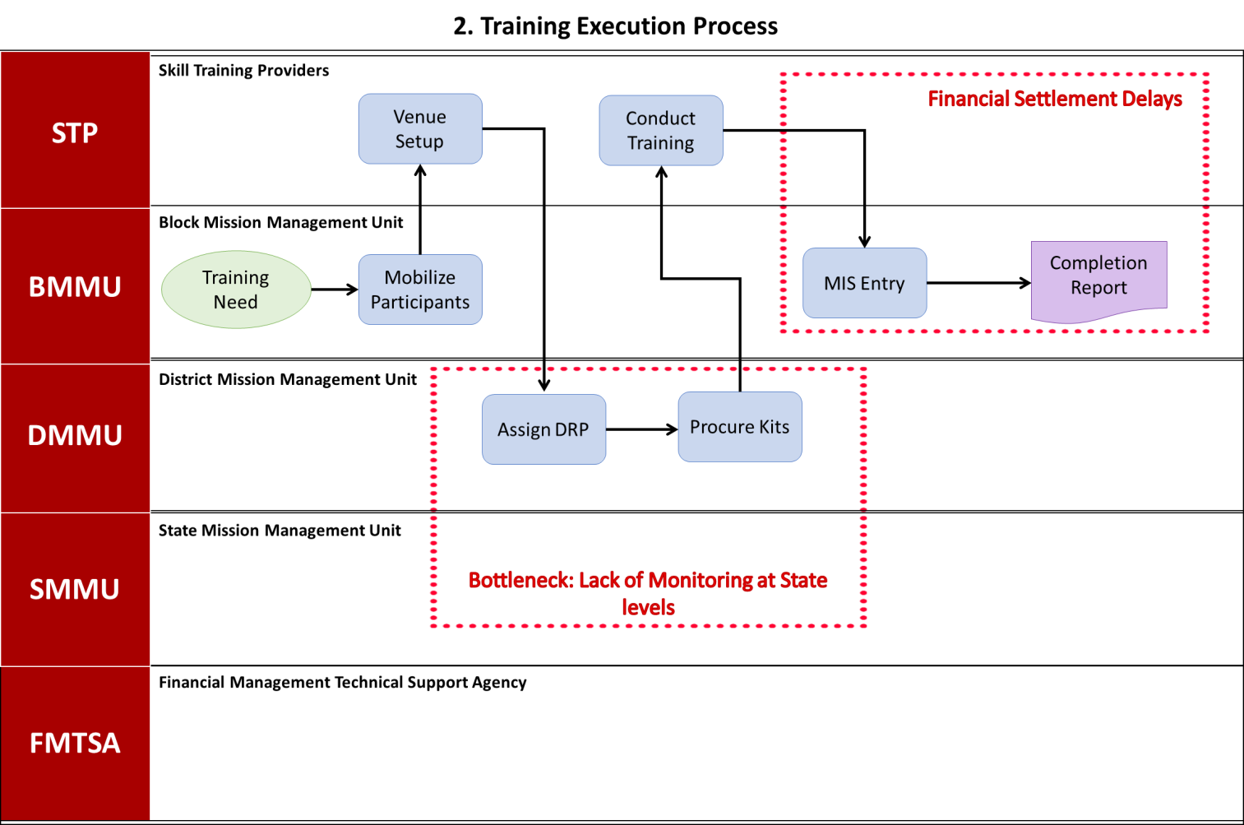
  - Training Execution Process Map File

  - Operational Workflows and Training Execution Logistics
    - Objective
To conduct training programs based on the approved AAP.
    - Process Steps
- Training Need: (BMMU) - A specific training need is identified.
- Mobilize Participants: (BMMU) - Participants are mobilized for the training.
- Procure Kits: (BMMU) - Training kits and materials are procured.
- Venue Setup: (Training Partner) - A suitable venue is set up for the training.
- Deploy CRPs: (BMMU) - Community Resource Persons are deployed to conduct the training.
- Conduct Training: (Training Partner) - The training program is conducted.
- MIS Entry: (BMMU) - Training data is entered into the Management Information System.
- Completion Report: (BMMU) - A training completion report is generated.
    - Organizational Levels Involved
- STP
- BMMU
- DMMU
- SMMU
- FMTSA

- Financial Management, PFMS, and Post-Training Settlement
A critical part of the "As-Is" process mapping involves the financial settlement procedures that occur after a training session is concluded. This is one of the most administratively dense areas of the mission's operations.
  - The Reimbursement Workflow
The current procedure for reimbursement and settlement of accounts is characterized by a multi-step verification process:
1. Expenditure Incurred: The training coordinator at the block or district level incurs the necessary expenses (venue, food, kits).
2. Bill Submission: Bills and vouchers are submitted to the DMMU along with the participant attendance list generated from the MIS.
3. MIS Entry: The district accountant ensures proper entries are made in Tally as per the budget heads.
4. PFMS Verification: The FMTSA or the district nodal officer verifies the expenditure on the PFMS portal to ensure compliance with the SNA framework.
5. Settlement: Funds are released to the respective account once the verification is complete.
  - Statutory Compliance and Audit
Training management is also subject to internal and statutory audits. CLFs are required to undergo quarterly internal audits and annual statutory audits, for which the mission provides specialized training for the procurement and audit committees. The FMTSA plays a vital role in ensuring that all financial statements—receipt and payment statements, balance sheets, and income/expenditure accounts—are prepared accurately for these audits.
  - Financial Settlement (Critical Bottleneck) Process Map
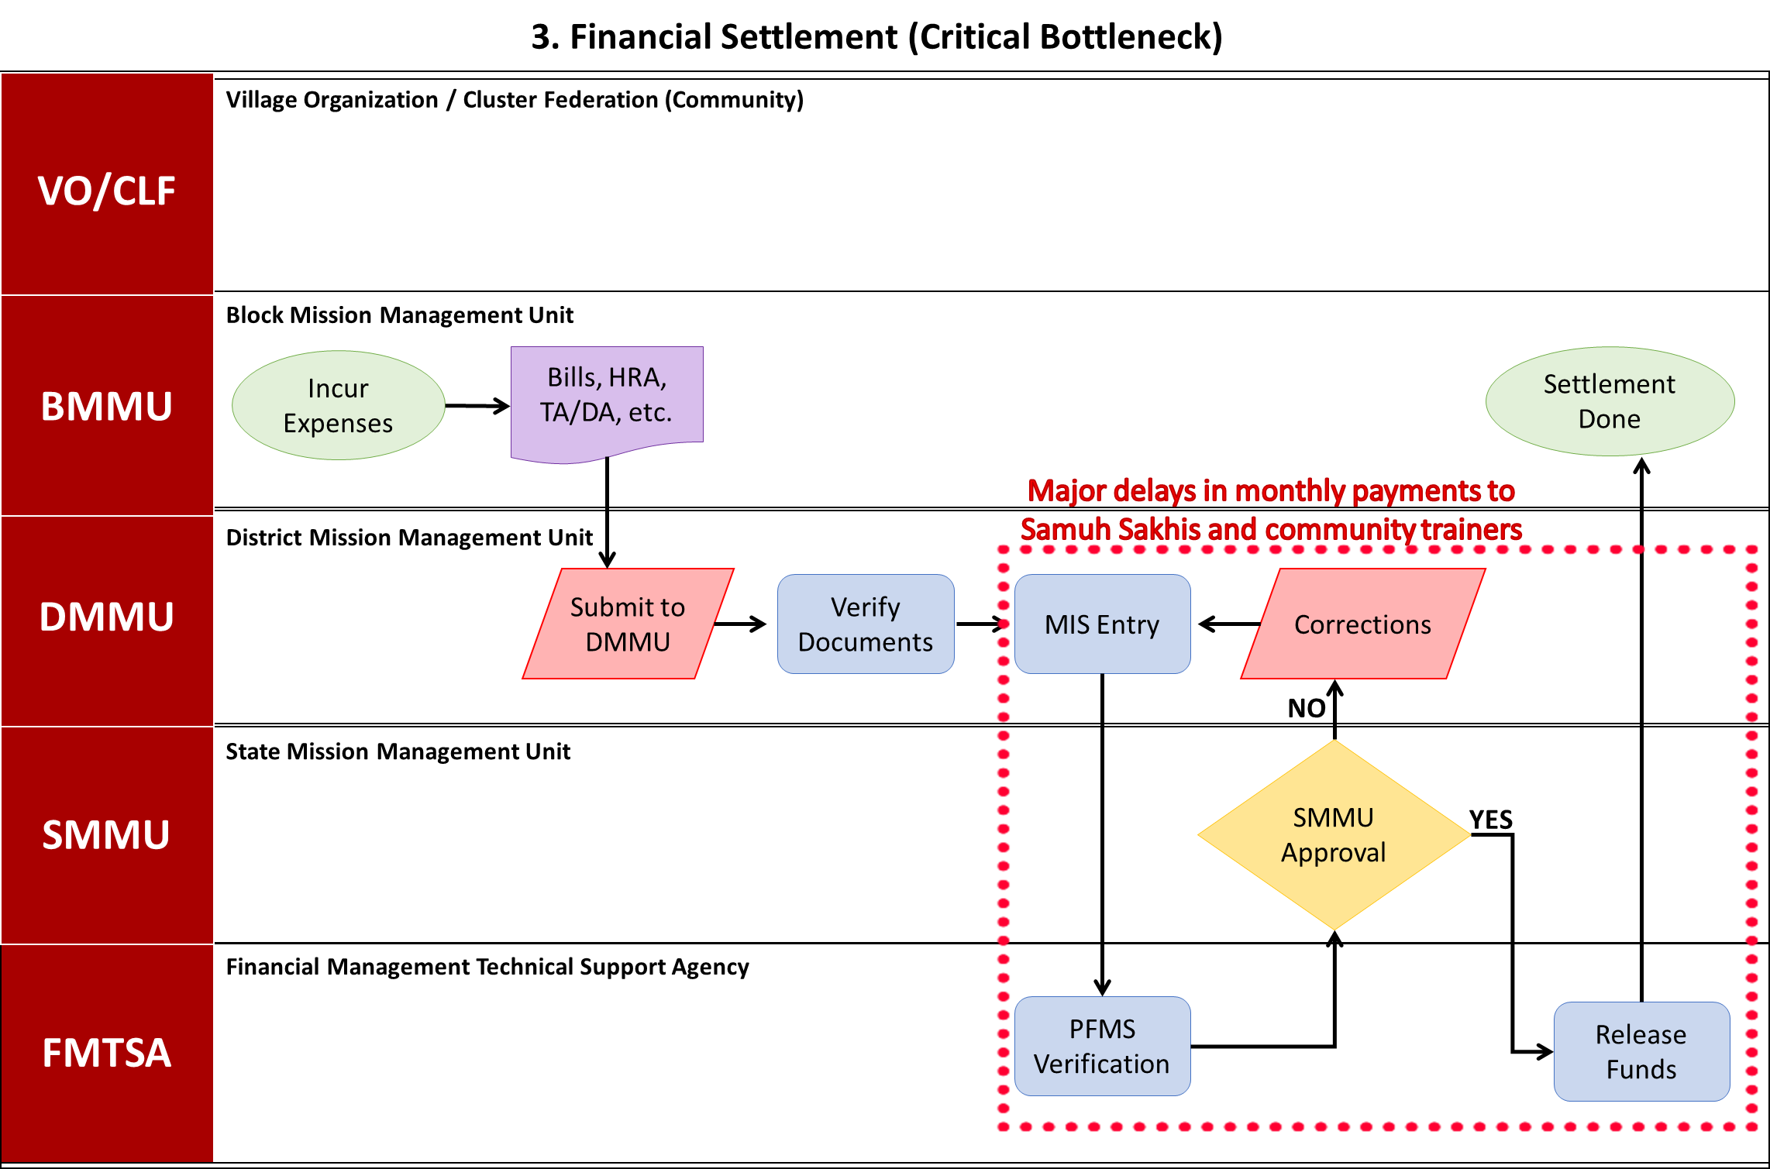
  - Financial Settlement Process Map File
  - Financial Settlement Operational Workflow
    - Objective
To reimburse expenses incurred during training execution.
    - Process Steps
- Incur Expenses: (BMMU) - Expenses are incurred for venue, food, etc.
- Bills & Vouchers: (BMMU) - Bills and vouchers are collected and prepared.
- Submit to DMMU: (BMMU) - Bills and vouchers are submitted to the District Mission Management Unit.
- DELAY: (DMMU) - Significant delay occurs in processing the documents.
- Verify Documents: (DMMU) - Documents are verified for accuracy and completeness.
- Tally Entry: (DMMU) - Expenses are entered into the Tally accounting system.
- PFMS Verification: (DMMU) - Verification is done through PFMS.
- Compliant? (DMMU) - Are the documents compliant with regulations?
  - Decision: Are the documents compliant?
    - No: Corrections (Goes back to step 5).
    - Yes: Release Funds (Proceeds to step 9).
- Release Funds: (DMMU) - Funds are released for reimbursement.
- Settlement Done: (BMMU) - Financial settlement is completed.
    - Organizational Levels Involved
- VO/CLF
- BMMU
- DMMU
- SMMU
- FMTSA
    - Identified Delays
- Months-long reimbursement cycles
- Verification Process
- Monthly Payment Delays to Community Cadre
    - Key Bottleneck
Financial Settlement Delays: Enormous delays in reimbursement procedures, often taking several months to complete.

- MIS and Real-Time Reporting
The UPSRLM Management Information System (MIS) serves as the primary tool for tracking training progress and ensuring data-driven decision-making.
  - Data Validation and Reporting Formats
Reporting formats in the MIS include the monthly Financial Progress Report (MPR) and the quarterly Interim Unaudited Financial Report (IUFR). However, the reliability of this data depends on the accuracy of the information entered at the block level. Discrepancies often arise when defunct or non-existent SHGs are still reported in the system. To mitigate this, the mission has introduced the "SHG maasik prativedan" as part of the standard bookkeeping to validate group-level data before it is aggregated in the MIS.
Report Type | Frequency | Primary Purpose
MPR (Financial Progress) | Monthly | Tracking actual vs. planned expenditure
IUFR (Interim Unaudited) | Quarterly | Accountability to MoRD and fund triggering
Vibrancy Assessment | Periodic | Identifying training needs and maturity
Bank Reconciliation | Monthly | Ensuring Tally-PFMS synchronization

  - Systemic Challenges and Procedural Bottlenecks
Despite the rigorous SOPs, the "As-Is" mapping reveals several friction points that hinder the efficiency of training management.
    - Administrative and Financial Delays
The most significant bottleneck is the "enormous delay and cumbersome procedure" for the reimbursement of training expenses. This often discourages staff from initiating training activities, as the lag between spending and reimbursement can be several months. Furthermore, there is a perceived lack of delegation of powers at the block and sub-block level, where even minor logistical approvals require sign-offs from the district or state units.
    - Reliability of Data and MIS Gaps
There are persistent issues with the reliability of MIS data regarding the number of new SHGs formed and their current status. Some groups that received Revolving Funds (RF) and Community Investment Funds (CIF) are now defunct but remain on the books, creating a skewed view of the mission's reach. The lack of rigorous data validation at the village entry level exacerbates these issues, necessitating joint exercises between field staff and block-level staff to clean the database.
    - Remuneration Delays for Community Cadres
Significant delays in channelizing monthly remuneration for Samuh Sakhis and other community trainers have been observed. This demotivates the very cadres who are responsible for mobilizing the community. Suggestions have been made to release six months of advance payment to nodal SHGs or VOs to ensure that these grassroots trainers are paid on time, thereby sustaining the momentum of the capacity-building effort.
    - Future Outlook and Institutional Sustainability
The long-term goal of training management at UPSRLM is to transition community institutions toward self-sustainability. This is achieved through a three-stage growth path: Early Stage, Maturation Stage, and Expansion Stage.
  - MIS Reporting Process Map
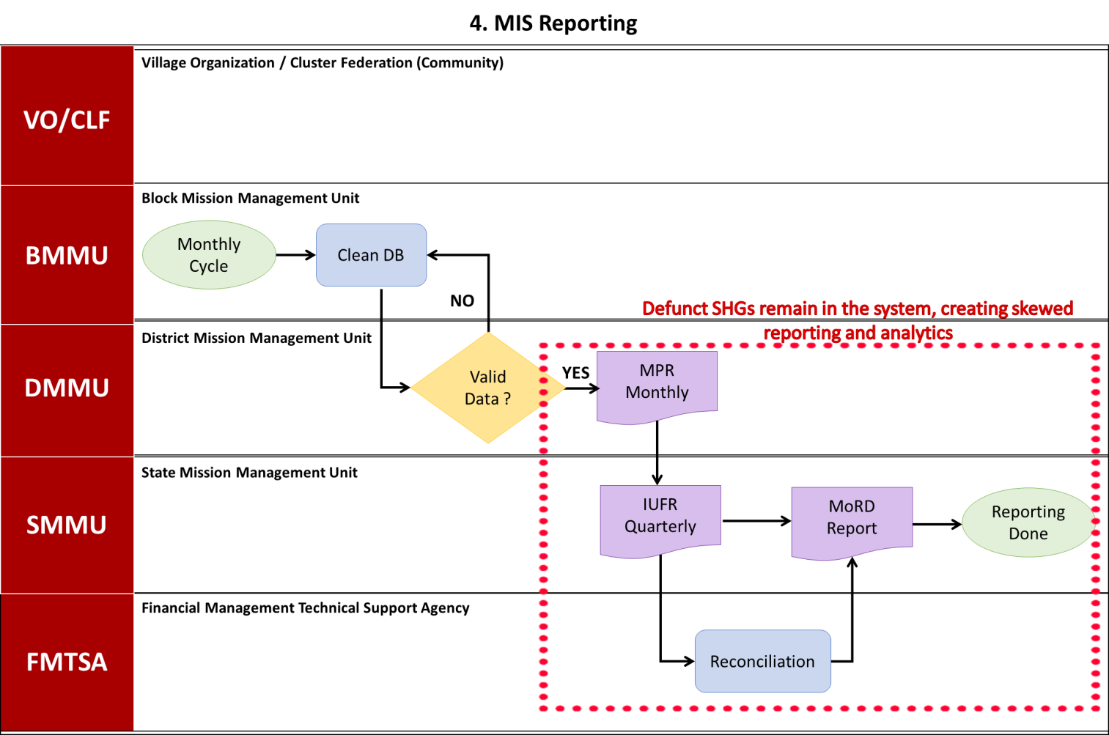
  - MIS Reporting Process Map File
  - Operational Workflow of MIS Reporting in UPSRLM
    - Objective
To generate reports for monitoring and evaluation.
    - Process Steps
- Monthly Cycle: (DMMU) - Data is collected on a monthly cycle.
- Data Entry: (DMMU) - Data is entered into the MIS.
- Valid Data? (DMMU) - Is the data valid and accurate?
  - Decision: Is the data valid?
    - No: Clean DB (Proceeds to step 4).
    - Yes: MPR (Proceeds to step 5).
- Clean DB: (DMMU) - The database is cleaned to remove defunct SHGs.
- MPR: (DMMU) - Monthly Progress Report is generated.
- IUFR: (DMMU) - Quarterly Interim Unaudited Financial Report is generated.
- Reconciliation: (SMMU) - Data is reconciled at the state level.
- MoRD Report: (SMMU) - Report is submitted to the Ministry of Rural Development.
- Reporting Done: (SMMU) - Reporting process is completed.

    - Organizational Levels Involved
- VO/CLF
- BMMU
- DMMU
- SMMU
- FMTSA

    - Identified Delays
- Data Validation
- Database Cleaning
    - Key Bottleneck
MIS Data Reliability: Defunct SHGs remain in the system, creating skewed reporting and analytics.
- Transition to Self-Governance
In the final "Expansion Stage" (Year 4 onwards), the mission's role shifts from intensive handholding to a mentoring relationship. CLFs are expected to operate as self-governed, self-reliant institutions with their own permanent service delivery systems. The capacity-building focus at this stage shifts toward advanced partnerships with government departments and high-level financial management.
  - Model CLFs and Lakhpati Resource Blocks
This section defines the human resource requirements necessary to deliver the project scope successfully. Resources are planned based on project complexity, phased delivery, role-based responsibilities, and shared Pragati Setu infrastructure, as reflected in the approved Resource Plan Excel.
  - Summary of Key Findings
- Total Process Steps: 39
- Decision Points: 3
- Identified Delays: 5
- Organizational Levels: 5 (VO/CLF, STP, BMMU, DMMU, SMMU, FMTSA)
This AS-IS process map provides a comprehensive overview of the UPSRLM Training Management System, highlighting areas that require attention to improve efficiency and effectiveness. Addressing the identified bottlenecks and delays will be crucial for enhancing the overall impact of the mission.

Disclaimer
- By reading the report, the reader accepts the terms and conditions mentioned hereunder.
- The scope of assignment is as per Contract between Third Party Auditor (BDO India LLP) and UPSRLM.
- This Report (“Report”) is prepared solely for the UP State Rural Livelihoods Mission (UPSRLM). This Report is intended for UPSRLM’s internal use only, subject to the terms and conditions mentioned therein may not be relied upon by other parties (“Third Party”). Neither this Report nor its contents may be distributed to, discussed with, or otherwise disclosed to any Third Party without the prior written consent of BDO India LLP (“BDO India” or “we” or “our” or “us”). Any other persons who choose to rely on these observations may do so entirely at their own risk.
- Our procedure and findings are based solely on the data, documentation, information and explanation that has been provided to us during the course of our engagement. In case, we come across information which may have bearing on the findings and observation made in this report subsequent to submission of report, we have no responsibility to update this Report. In circumstances, where any additional information become available from or with respect to the engagement to us, we would be glad to carry out additional procedure as may be separately agreed with the Client.
- The work carried out and analysis presented in this Report are based on the result of our discussion with representatives of UPSRLM and are not always supported by written documentation. We make no representation regarding the sufficiency of the procedures performed either for the purpose for which this engagement was sought or for any other purpose. Findings are based on circumstantial evidence and partially concluded in the absence of adequate supporting / documents.
- We have relied on the information provided by the UPSRLM and our observations are based primarily on the review of such information. In respect of the information in soft copy form received from the UPSRLM, no independent verification with the original documents is carried out.
- This Report does not constitute an engagement to provide audit, compilation, review, or attestation services made in accordance with the generally accepted auditing standards in India and, consequently, no assurance will be expressed. Our work would not be any expression of an opinion or testimony of expert witness. In any manner, the engagement does not extend to provide advice, analysis and observations relating to legal and regulatory issues.
- In no circumstances shall we be liable, for any loss or damage, of whatsoever nature, arising from information material to our work being withheld or concealed from us or misrepresented to us by any person of whom we made information requests at the bank or on field.
- BDO India LLP has executed detailed work steps as identified and agreed in our scope of work.
- We assume no responsibility for the accuracy and completeness of information, that cost/benefit and other considerations will preclude us from pursuing every conceivable source of information. Further, we have used professional judgment to identify the information source to be searched. If other professional undertook similar procedures on the same subjects, such professionals might provide different findings. Accordingly, we do not provide assurance that all information will be available in the public and private domain.
- UPSRLM shall be fully and solely responsible for applying independent judgment, with respect to the findings included in this Report, to make appropriate decisions in relation to the future course of action, if any. BDO India shall not take responsibility for the consequences resulting from decisions based on information included in the report.
- BDO has not identified, addressed or corrected any errors or defects in the computer systems, other devices or components thereof (“Systems”), whether or not due to imprecise or ambiguous entry, storage, interpretation or processing or reporting of data. We will not be responsible for any defect or problem arising out of or related to data processing in any Systems.
- Our reports and comments should not be considered a definitive pronouncement on the individual or the company.
- When assisting the Client in the Performance of BDO India’s activities, BDO India has not:
- Determined which, if any, recommendations should be implemented;
- Acted on behalf of management in reporting to the Board of Directors, or Audit Committee;
- Have custody of assets;
- Act in any capacity equivalent to a member of management or an employee;
- Assess the quality of source data;
- Held liable, for any loss or damage, of whatsoever nature, arising from analysis.
- Approved, or be responsible for, the overall fraud risk assessment work, including the ultimate assessment of review risk, determination of scope, project priorities and frequency of Performance of audit procedures.

WHAT MATTERS TO YOU,
MATTERS TO US.

FOR MORE INFORMATION:
Anurag Srivastava- Partner
+91 – 9717004947| AnuragSrivastava@bdo.in

BDO INDIA LLP, an Indian limited liability partnership, is a member of BDO International Limited, a UK company limited by guarantee, and forms part of the international BDO network of independent member firms.

BDO is the brand name for the BDO network and for each of the BDO Member Firms.
Copyright © Aug 2021, BDO INDIA LLP. All rights reserved.
www.bdo.in

